SPEARMAN’S RANK CORRELATION
Spearman’s correlation measures how well two things move together in terms of rank (positions), not actual values. It answers the question, if one variable increases, does the other also increase (or decrease) in a consistent pattern?
WHY IS IT USED:
When data is not normally distributed
When data is ordinal (ranked)
It measures the degree of monotonic relationship between two variables.
A monotonic relationship means:
- As one variable increases, the other always increases
(positive monotonic)
OR
- As one variable increases, the other always decreases
(negative monotonic)
It converts raw scores into ranks, then checks:
- If the ranks are similar → positive correlation
- If ranks oppose each other → negative correlation
- If ranks are random → no correlation
The more the two ranking orders match, the stronger the correlation

FORMULA:
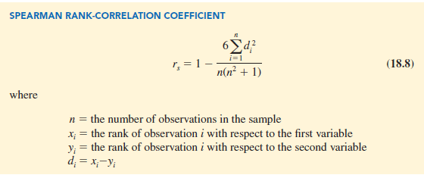

Spearman’s Correlation Valuation Meaning
+1 | Perfect positive relation (ranks move together exactly)
0 | No relation in the ranks
–1 | Perfect negative relation (ranks move opposite)

HOW TO FIND THE ANSWER THROUGH FORMULA
- Rank the data (if ranks not given)
- Find d = difference in ranks
- Square it: d²
- Add all d²
- Substitute in formula
- Calculate the value
FOR EXAMPLE:
Suppose we have marks in Maths and English for 5 students.
Student | Maths Rank | English Rank
A | 1 | 2
B | 2 | 1
C | 3 | 3
D | 4 | 4
E | 5 | 5

STEP 1: Find the difference (d)
$$d=\text{Maths Rank}-\text{English Rank}$$
Student | Maths Rank | English Rank | d | d²
A | 1 | 2 | -1 | 1
B | 2 | 1 | 1 | 1
C | 3 | 3 | 0 | 0
D | 4 | 4 | 0 | 0
E | 5 | 5 | 0 | 0

STEP 2: Add all d² values
$$∑d^{2}=1+1+0+0+0=2$$

STEP 3: Put into the formula
$$n=5 \\ ρ=1-\frac{6∑d^{2}}{n(n^{2}-1)} \\ ρ=1-\frac{6(2)}{5(25-1)} \\ ρ=1-\frac{12}{5×24} \\ ρ=1-\frac{12}{120} \\ ρ=1-0.1=0.9$$

Final Answer: Spearman’s correlation = 0.9
0.9 means a very strong positive relationship between the two subjects.

Meaning in Real Life
Spearman answers questions like:
- “Do students who score high in Maths also score high in Science?”
- “Do people who like spicy food also like horror movies?”
- “Do richer people also have larger houses?”
- “Do employees with more experience always get higher salaries?”
QUIZ TO TEST YOUR UNDERSTANDING OF THE TOPIC
What does Spearman’s Rank Correlation measure?
a) Linear relationship between two variables
b) Relationship between the ranks of two variables
c) The average of two datasets

What kind of relationship does Spearman’s Rank Correlation measure?
a) Only linear relationships
b) Any monotonic relationship (increasing or decreasing)
c) Only relationships with normally distributed data

If the Spearman correlation between two variables is +1, what does it mean?
a) Ranks move in opposite directions
b) No relationship
c) Perfect positive monotonic relationship

What value will Spearman’s correlation take if two variables have completely opposite ranks?
a) +1
b) –1
c) 0

Which step is NOT part of calculating Spearman’s correlation?
a) Ranking the data
b) Finding the difference between ranks
c) Finding the difference between actual raw values

